1. Client Problem Statment

Need to have you make a information system about customer of cd/dvd film use web based application, which enable to create,edit,delete, and update as many web pages as possible with easy to administrate dashboard. This apllication must be have a login page to secure. Administrator can be create, edit, delete, and update data. The design must be beautiful and than i will also need ability to manage widget than apears on sidebar areas of application. And the last is this application running in localhost not internet.

# summary from client problem statment

1. make a information system about customer of cd/dvd film use web based application.

2. administrator enable to create, edit, delete, update the data

3. application must be have login page to secure

4. the desing must be beautiful

5. application running in localhost

2. DVD Level 0

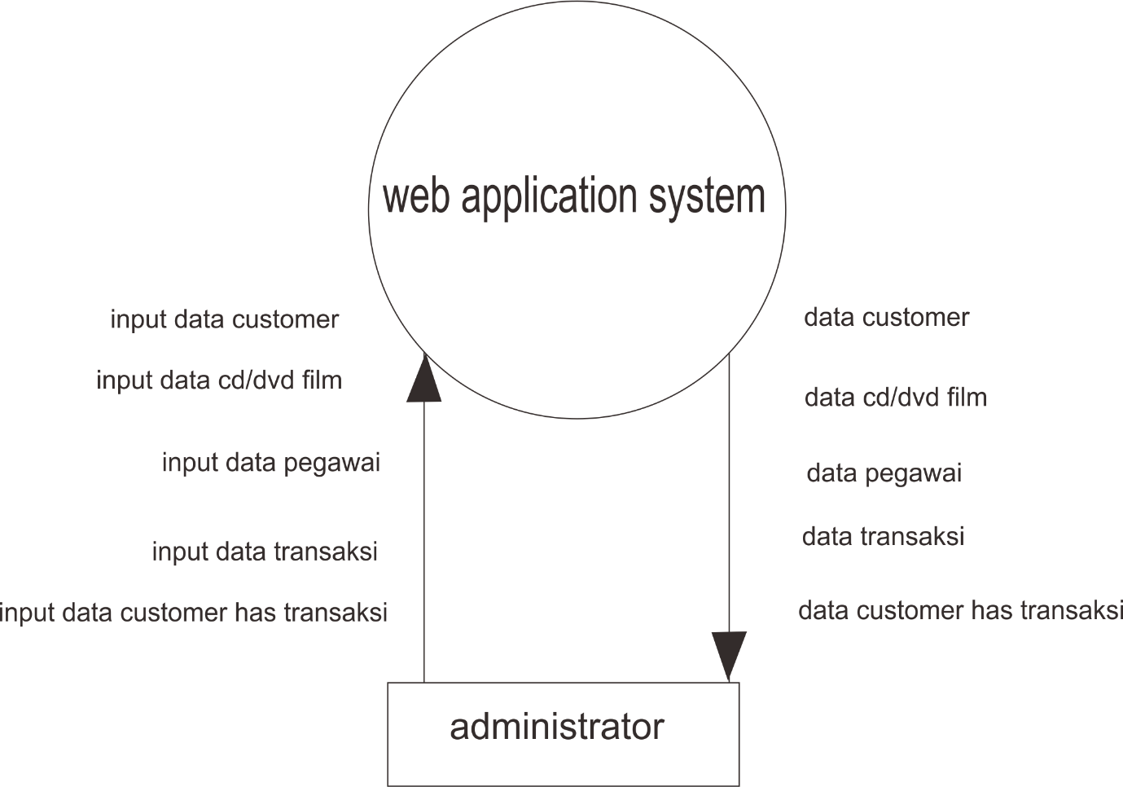

3. Use Case Diagram

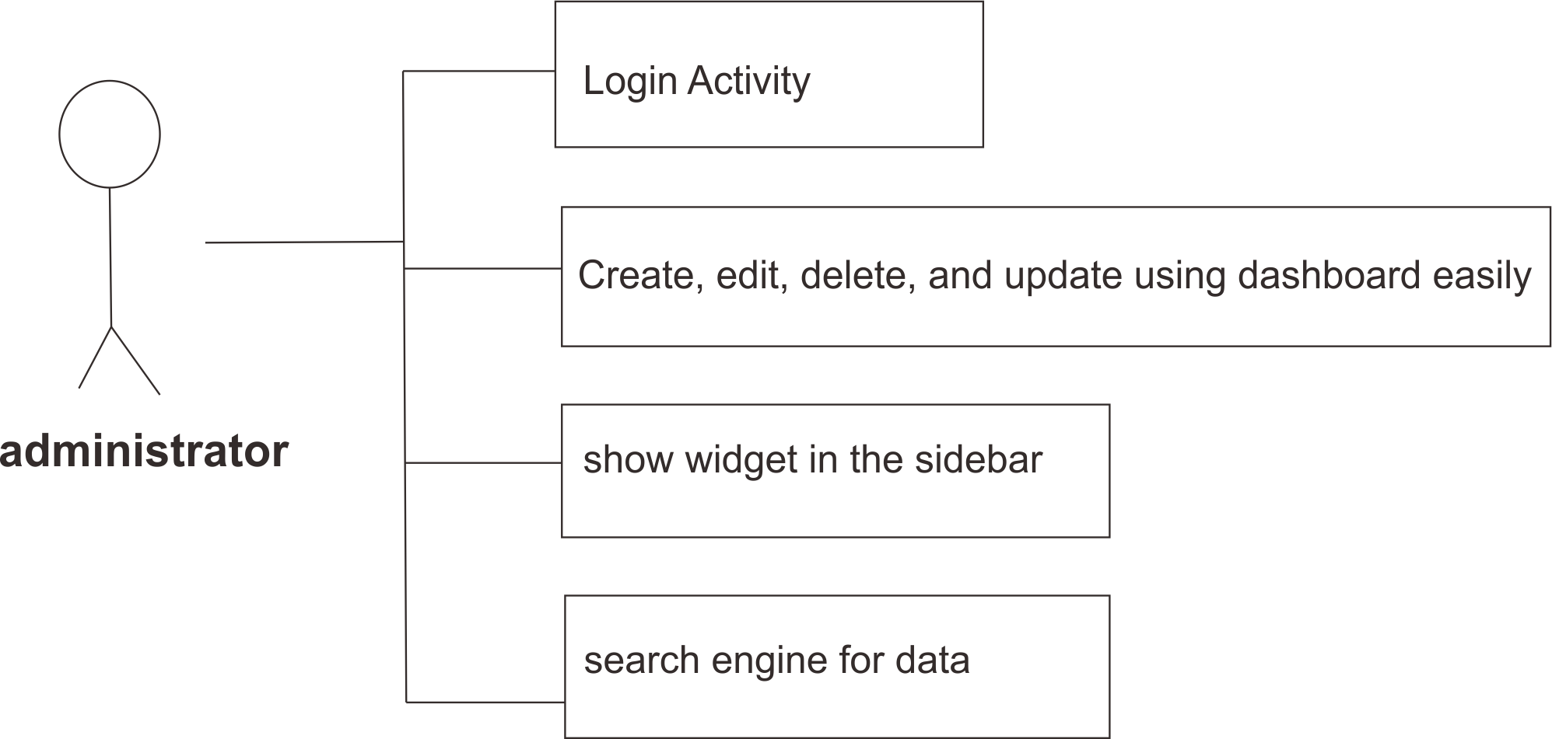

4. How the system work

The system will be work, we have 1 member this is administrator. This administrator will be login and the administrator will be create, edit, delete, and update data and search data. Example customer, pegawai,transaksi, data cd/dvd film, and customer has transaksi.

5. Login Activity

